Ideation & Design Phase
Problem - Solution Fit Canvas
Date | 03 October 2026
Developer / Student | Vinay Krishna A K
Project Name | Automated Network Request Management in ServiceNow

- Problem - Solution Fit Canvas 2.0

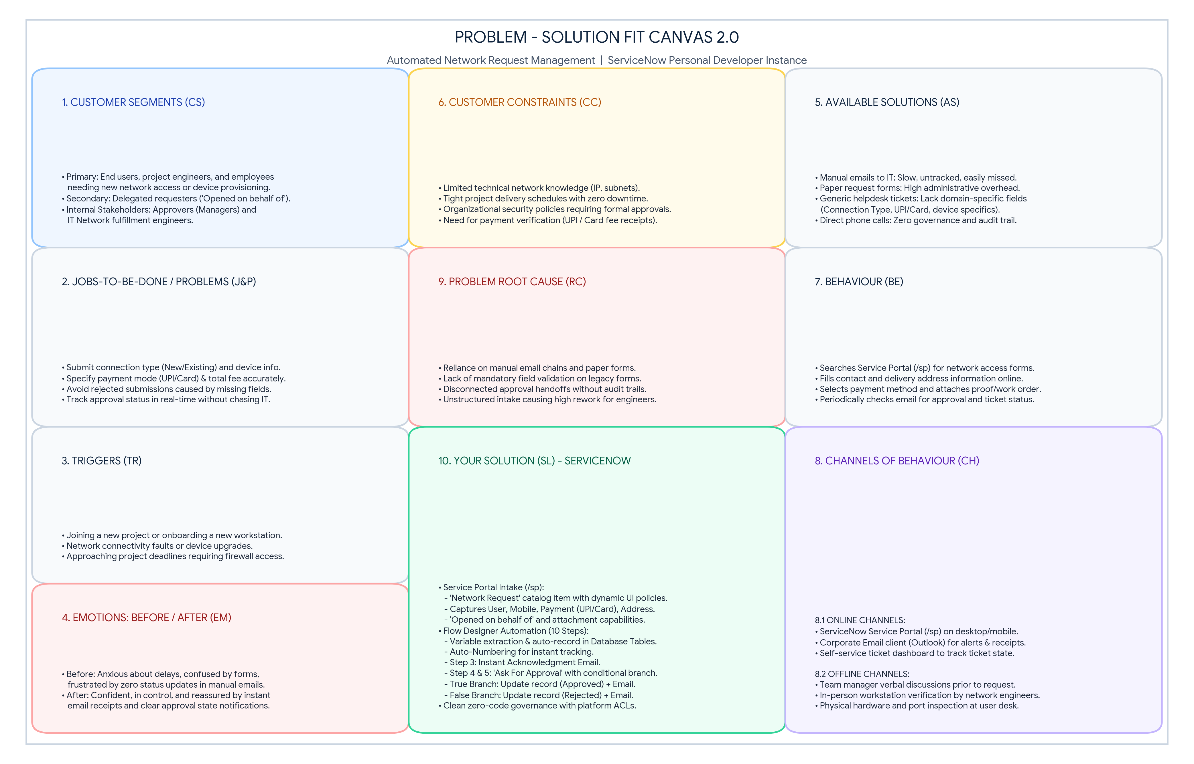

- Canvas Dimensions Breakdown (ServiceNow Implementation)

Section No. | Canvas Dimension | ServiceNow Project Analysis & Configuration
1. CS | Customer Segment(s) | End users, employees, and engineers needing network access or device setup. Includes delegated requesters ('Opened on behalf of') and line managers acting as approvers.
2. J&P | Jobs-To-Be-Done / Problems | Submit network connection details (New/Existing), calculate Total Amount, choose Mode of Payment (UPI/Card), provide delivery Address, and receive timely approvals without administrative delays.
3. TR | Triggers | Starting a new project, joining a team, relocating workstations, encountering network connection issues, or needing authorized port access.
4. EM | Emotions (Before / After) | Before: Anxious about missing project deadlines, confused by complex legacy procedures, and stressed by unacknowledged emails.  After: Reassured, in control, and confident due to instant acknowledgment emails and visible progress.
5. AS | Available Solutions | Manual email threads to IT engineers, physical paper request forms, and generic incident tickets. Drawbacks: zero automated approval routing, missing fields, and high triage overhead.
6. CC | Customer Constraints | Lack of technical network expertise, strict security compliance policies, reliance on line-manager sign-offs, and requirement of valid payment modes (UPI/Card).
7. BE | Behaviour | Opens the corporate portal, searches for network items, fills in required contact/connection details, attaches documents, and checks email for status updates.
8. CH | Channels of Behaviour | Online: ServiceNow Service Portal (/sp), automated email notifications, and self-service request status widgets.  Offline: Direct manager discussions and on-site hardware setup by network engineers.
9. RC | Problem Root Cause | Absence of an integrated, automated intake and workflow engine. Legacy systems lacked mandatory validation, dynamic field rules, and automated database record creation.
10. SL | Your Solution (ServiceNow) | Service Portal Catalog Item (/sp) with dynamic Catalog UI Policies, custom relational schema Database Tables (u_database_table) with Auto-Numbering, and a 10-step Flow Designer automation routing approvals, setting record states, and sending automated emails.

